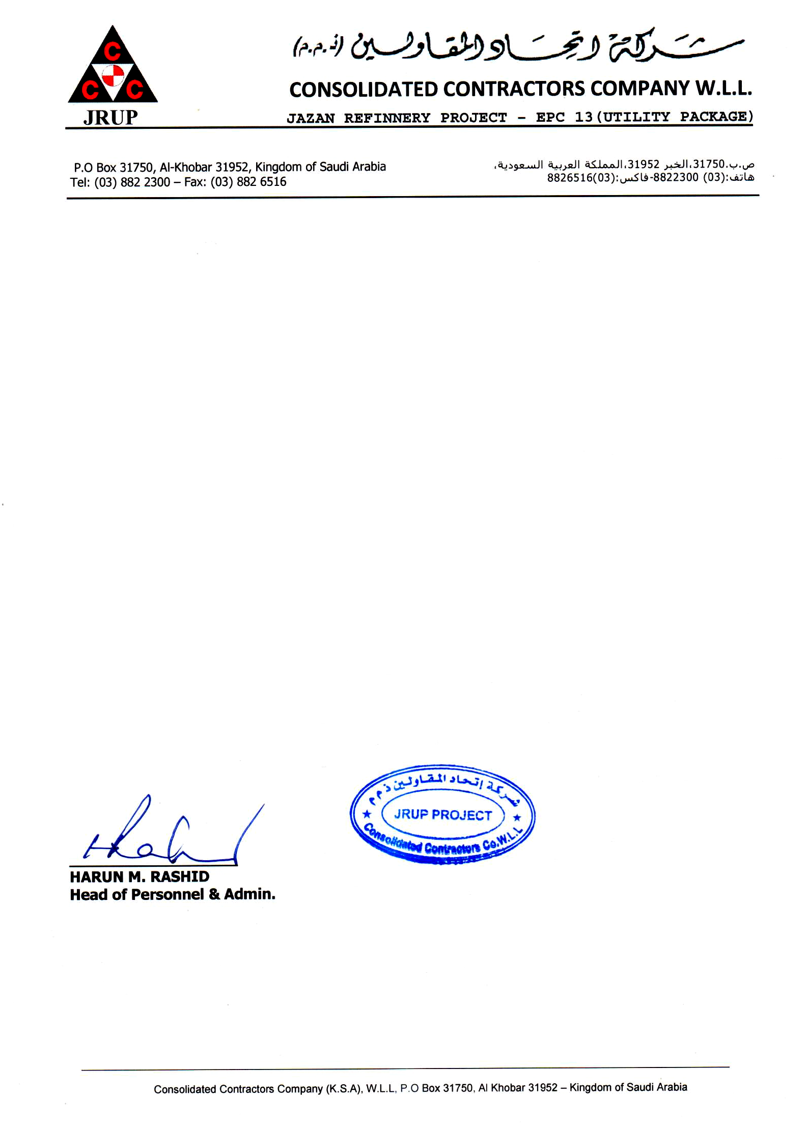

Date: <To2> Ref: ADM/018/JRUP/159143

TO WHOM IT MAY CONCERN

This is to certify that Mr. <Name> Pakistan Nationality Holding Passport No. <Passport> was working with CCC a JRUP Project from <From2> Up to his release date on <To2> in the Capacity of <Designation>.

This certificate is given to him upon his request without any obligation towards the company.

For Consolidated Contractors Company W.L.L.